Homework to be completed for Friday 15th September
Practise your spellings
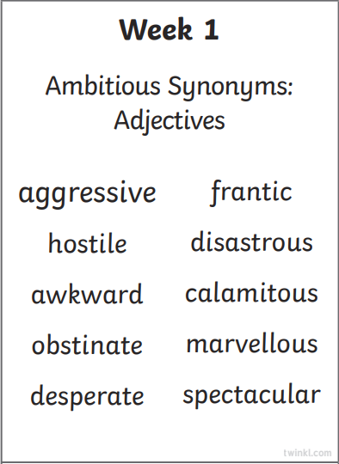
Complete the following:
Maths Key Skills S5 Check 1
Grammar Hammer S5 Check 1
Comprehension sheets.



