St. Peter’s Catholic Primary School | Year 5 | Autumn Term 2025/26 | Teacher: T Drury

Core Teaching Principles  (Pedagogy) | Sequencing concepts and modelling  Present new material using small steps.  Provide models.  Scaffolding. | Questioning  Ask a range of open and differentiated questions to explore and extend understanding  and reasoning skills.  Targeted questioning | Reviewing  Revisit prior learning.  Build on prior knowledge and experience. | Stages of practice  Whole class/shared.  Guided practice  Independent practice. | Collaborative learning  Learning partners  Kagan strategies | Communication  Oracy  Speaking and listening activities  Explicit teaching of vocabulary  Modelling by adults | Active  Participation  No hands up  Lolly sticks  Targeted questions | Metacognition  Reflection of learning strategies that help them as a learner  Modelling/Think aloud by adults  Critique/self evaluation/peer evaluation

Literacy |  | TERMLY TOPIC FOCUS:  Autumn 1 – Geography  Europe  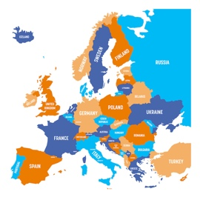  Over-riding theme: Why do people move countries?  Autumn 2 – History  Britian’s settlement by the Anglo Saxons  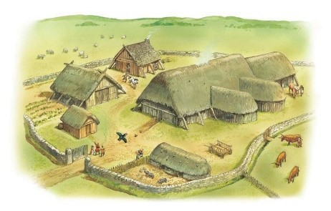 |  | MATHEMATICS
Writing  Autumn 1 - Focus text: The Ever-Changing Earth by Grahame Baker-Smith  Main outcome: Travel leaflet  Purpose: To inform  Audience: The public / tourists  Autumn 2 - Focus text: Arthur and the Golden Rope  by Joe Todd-Stanton  Main outcome: A journal entry  Purpose: To entertain  Audience: Arthur |  |  |  | White Rose Maths Programme  Block 1 – Place Value  Block 2 – Addition and subtraction  Block 3 – Multiplication and division A  Block 4 - Fractions A
Reading

Whole class reading sessions following six-part sequence.
Whole class reading text: Sky Song by Abi Elphinstone.

Regular Reading for Pleasure opportunities.

Weekly visit to the school library to exchange library books.

SPaG

Grammar objectives to be taught contextually within writing units.

Spelling rules and common exception words to be taught discreetly and consolidated in all writing activities.

GEOGRAPHY |  | SCIENCE |  | RE
Over-riding theme: Why do people move countries?  Autumn: Europe  - Can you name and locate the countries of Europe?  - Can you give examples of how some boundaries have changed over time?  - What are the capital cities of some major European countries?  - How do the time zones differ across Europe and the world?  - Can you name some of the mountain ranges in Europe?  - What are the main rivers in Europe?  - What are the main climate zones in Europe? How do the climate zones of the UK and Spain compare? How do these effect the economic activity of each? |  | Autumn 1 - Living things and their Habitats  - Significant individuals- David Attenborough  NC Objectives  - Describe the differences in the life cycles of a mammal, an amphibian, an insect and a bird.  - Describe the life process of reproduction in some plants and animals.  Autumn 2 - Animals, including Humans  - Significant individuals- Elizabeth Blackwell  NC Objectives  - Describe the changes as humans develop to old age. |  | To Know You More Clearly Programme  Autumn 1  - Branch One: Creation and covenant  Autumn 2  - Branch Two: Prophecy and promise
HISTORY |  | ART and DESIGN TECHNOLOGY |  | PE
Invaders and Settlers  Autumn: Britian’s settlement by the Anglo Saxons  - Where are English people from?  - Are all English people migrants?  - Why isn’t England part of the Roman Empire today?  - Why did the Anglo Saxons come to England?  - Who was the first king of England?  - Was England always a Christian country?  - Who wrote history books in Anglo Saxon times?  - Who was buried at Sutton Hoo? |  | Art  Autumn 1 – Drawing / mark-making  - Jackie Morris – book illustrator  - Animal illustrations  Autumn 2 – Printing  - Block print  - Anglo Saxon / Viking jewellery  Design technology  Twinkl Programme  - Marbulous structures |  | Get Set 4 P.E. Programme  Autumn 1  - Gymnastics  - Tag rugby  Autumn 2  - Dance  - Hockey
COMPUTING |  | PSHE / RSE |  | MUSIC
Teach Computing Programme  Autumn 1  - Systems and searching  Autumn 2  - Video production |  | TenTen Life to the Full Plus Programme  Autumn 2  Module 1, Unit 1  Module 2 Unit 1 |  | Charanga Programme  Autumn 1  - Livin’ On a Prayer  Autumn 2  - Classroom Jazz 1

