St. Peter’s Catholic Primary School | Year 5 | Summer 2 2025/26 | Teacher: T Drury

Core Teaching Principles  (Pedagogy) | Sequencing concepts and modelling  Present new material using small steps.  Provide models.  Scaffolding. | Questioning  Ask a range of open and differentiated questions to explore and extend understanding  and reasoning skills.  Targeted questioning | Reviewing  Revisit prior learning.  Build on prior knowledge and experience. | Stages of practice  Whole class/shared.  Guided practice  Independent practice. | Collaborative learning  Learning partners  Kagan strategies | Communication  Oracy  Speaking and listening activities  Explicit teaching of vocabulary  Modelling by adults | Active  Participation  No hands up  Lolly sticks  Targeted questions | Metacognition  Reflection of learning strategies that help them as a learner  Modelling/Think aloud by adults  Critique/self evaluation/peer evaluation

Literacy |  | TERMLY TOPIC FOCUS:  The legacy of Anglo-Saxons and Vikings on Britian today  Summer 2 – History  Enquiry questions  • What effects did the Anglo Saxons and Vikings have on English history?  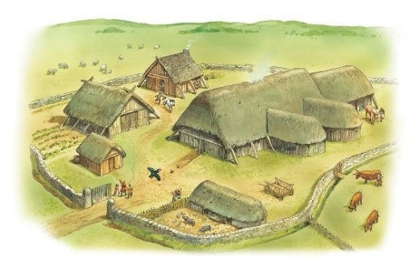  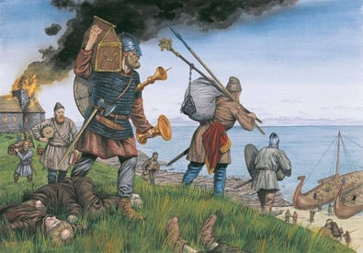  • What evidence of their settlement can we see in our lives today? |  | MATHEMATICS
Writing  Focus text:  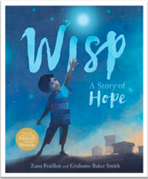  Wisp - A Story of Hope by Zana Fraillon and Grahame Baker-Smith  Main outcome: To write a narrative from the point of view of the Wisp  Purpose: To entertain  Audience: People in need of hope |  |  |  | White Rose Maths Programme  Block 12 – Decimals  Block 13 – Negative numbers  Block 14 – Converting units  Block 15 – Volume
Reading

Whole class reading sessions following six-part sequence.

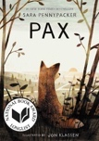
Whole class reading text: Pax by Sara Pennypacker

Regular Reading for Pleasure opportunities.

Weekly visit to the school library to exchange library books.

SPaG

Grammar objectives to be taught contextually within writing units.

Spelling rules and common exception words to be taught discreetly and consolidated in writing activities.

GEOGRAPHY |  | SCIENCE |  | RE
 |  | Summer 2 - Forces  - Significant individuals: Archimedes  NC Objectives  Pupils should be taught to:  - explain that unsupported objects fall towards the Earth because of the force of gravity acting between the Earth and the falling object  - identify the effects of air resistance, water resistance and friction, that act between moving surfaces  - recognise that some mechanisms, including levers, pulleys and gears, allow a smaller force to have a greater effect |  | To Know You More Clearly Programme  Summer 2  - Branch Six: Dialogue and Encounter
HISTORY |  | ART and DESIGN TECHNOLOGY |  | PE
The legacy of Anglo-Saxons and Vikings on Britian today  Summer 2 – History  Enquiry questions  • What effects did the Anglo Saxons and Vikings have on English history?  • What evidence of their settlement can we see in our lives today? |  | DT  - Super Seasonal Cooking |  | Get Set 4 P.E. Programme  Summer 2  - Rounders  - Basketball
COMPUTING |  | PSHE / RSE |  | MUSIC
Teach Computing Programme  Summer 2  - Programming B |  | TenTen Life to the Full Plus Programme  Summer 2  UKS2 Module 3, Unit 2 |  | National Schools Singing Programme – delivered through the Diocese of Hallam

