St. Peter’s Catholic Primary School | Reception | Autumn | Teacher: C Bleything

Core Teaching Principles  (Pedagogy) | Sequencing concepts and modelling  Present new material using small steps.  Provide models.  Scaffolding. | Questioning  Ask a range of open and differentiated questions to explore and extend understanding  and reasoning skills.  Targeted questioning | Reviewing  Revisit prior learning.  Build on prior knowledge and experience. | Stages of practice  Whole class/shared.  Guided practice  Independent practice. | Collaborative learning  Learning partners  Kagan strategies | Communication  Oracy  Speaking and listening activities  Explicit teaching of vocablary  Modelling by adults  Communicating the Curriculum/Voice 21 | Active  Participation  No hands up | Metacognition  Reflection of learning strategies that help them as a learner  Modelling/Think aloud by adults  Critique/self evaluation/peer evaluation

ENGLISH |  | TERMLY TOPIC FOCUS:  Autumn: Me and my family / Traditional Tales / Seasons and Celebrations  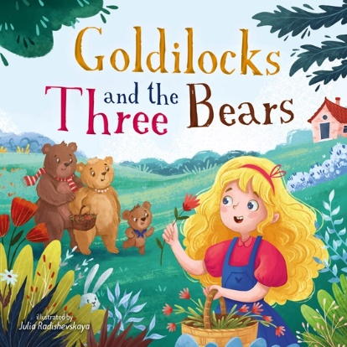 |  | MATHEMATICS
Writing  Core text: Goldilocks and the Three Bears,  The Gingerbread Man  Purpose: Link to traditional tales.  Audience: Display/twitter. |  |  |  | WHITE ROSE HUB  - Getting to know you  - Match, Sort and Compare  - Talk about measures and patterns  - It’s Me, 1-2-3!  - Circles and Triangles  - 1,2,3,4,5  Shapes with 4 sides
Reading
Guided reading 3 x per week (Little Wandle)
Story time at the end of the day.

GEOGRAPHY |  |  |  |  |  |  |  | RE
Autumn: Me and my family / Traditional Tales / Seasons and Celebrations  What is happening to the trees?  What signs of autumn/winter are there in the school grounds?  What is it like outside our classroom? What is the weather like today?  Do you know any places that are special to members of your community?  Why do Followers of Judaism celebrate Hanukkah?  Why do Christians celebrate Christmas?  See separate MTP for more detail |  |  | See separate MTP for more detail |  |  |  |  | Branch 1 – Creation and Covenant  Show a cross and explain that this is a symbol of a Christian, a person who believes in God.  Listen and echo the words, ‘In the name of the Father, and of the Son, and of the Holy Spitit, Amen.’  God loves us and we are part of a family.  God made me.  God made each one of us as a unique person.  See separate MTP for more detail
HISTORY |  |  | ART and DESIGN TECHNOLOGY |  |  |  |  | PE
Understanding the World  Know who is in my family. Know how have I changed over time.  Know why am I special.  Special Celebrations.  Know how we can celebrate and remember special events.  Birthdays. Happen every year. ·  Liturgical celebrations, Christmas, Easter, Pentecost. Celebrated in different ways. Know these ways. ·  Remembrance Day. Begin to know about the day by talking about loss in their own lives and remembering past events in their own lives. Know that poppies are a symbol of remembrance. ·  Bonfire Night ·  Chinse New Year  See separate MTP for more detail |  |  | FOCUS: mark making/  drawing, painting  ARTIST: Picasso  Know how to create lines,  meaningful marks with a  variety of mediums and  tools.  Pencil, pens, chalk, paint,  water, brush, fingers.  Know that we can study  and draw our own face.  Observe faces through  photographs, illustrations  and mirrors.  Use practised mark  making skills to draw  characters Goldilocks and  the Three Bears with  paint.  Know that Picasso drew  self portraits in many  different ways.  Look at various portraits  by Picasso, give opinions  on what can be seen. |  |  |  |  | Outdoor provision  Cosmic Yoga
 | PSHE |  |  |  | MUSIC
 | Ten Ten Resources  Module 1 – Created and loved by others.  Module 2 – Created to love others. |  |  |  | Charanga Scheme  Autumn 1 – ME!  Autumn 2 – My Stories!

