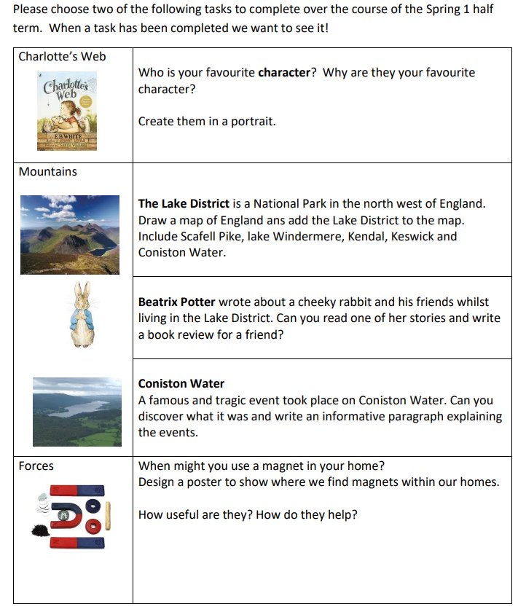
Please choose just two of the tasks below to complete at home and bring in to share with the class.
Please remember to continue reading, logging on to Times Table Rock Stars, and learning spelling words.

